Annex A Revised 2022

Republic of the Philippines
Province of Nueva Ecija
San Jose City – 3121
-oOo-

STRATEGIC PERFORMANCE MANAGEMENT SYSTEM (SPMS)

MAJOR FINAL OUTPUTS

MAJOR FINAL OUTPUT (OPCR) | OUTPUTS  (IPCR) | PERFORMANCE MEASURES | PERFORMANCE TARGETS | SUCCESS INDICATOR | ORGANIZATIONAL OUTCOME / SECTORAL GOALS

Annex B Revised 2022
Region : 3 2
Province : NUEVA ECIJA a
City : SAN JOSE CITY _ a

OFFICE PERFORMANCE COMMITMENT AND REVIEW FORM
OFFICE PERFORMANCE COMMITMENT AND REVIEW (OPCR)

I, ______________________________________, Head of the __________________________________, commit to deliver and agree to be rated on the attainment of the following targets in accordance with the indicated measures for the period ______ to ______, 20 ___.

________________________________
Department Head

Date: ___________________________

Approved by*
Date
City Mayor
Head of Agency

MFO/PAP | SUCCESS INDICATORS (TARGETS + MEASURES) |  |  | Allotted Budget | Division/  Individuals Accountable |  | Actual Accomplishments | Rating |  |  |  |  | Remarks
 |  |  |  |  |  |  |  | Q² | E² | T³ | A² |  | Remarks
STRATEGIC PRIORITY
SUPPORT FUNCTIONS
Average Rating
CATEGORY |  |  |  | MFO |  |  | Rating
Strategic Priority
Core Functions
Support Functions
Total Overall rating
Final Average Rating
Adjectival Rating
Assessed by: |  |  |  |  |  |  | Final Rating by: |  |  |  |  | Date
 |  | Date |  |  |  | Date
Planning Office |  | Date | PMT |  |  | Date | Head of Agency
Legend: 1 – Quantity 2. Efficiency 3. Timeliness 4. Average

5 – Outstanding 1 - Poor
4 – Very Satisfactory
3 – Satisfactory
2 - Unsatisfactory

Annex C Revised 2022

Region : 3 2
Province : NUEVA ECIJA a
City : SAN JOSE CITY _ a
SPMS CALENDAR

Activity | Submit to | Schedule
 |  | Jan | Feb | Mar | Apr | May | Jun | Jul | Aug | Sep | Oct | Nov | Dec
- Performance Planning and Commitment
OPCR for review | PMT |  |  |  |  |  |  |  |  |  |  |  | Within 15 days before and 15 days after the rating period
PMT review report |  |  |  |  |  |  |  |  |  |  |  |  | -do-
IPCR | Head of Office |  |  |  |  |  |  |  |  |  |  |  | Within 90 days before the start of rating period
 | CHRMO |  |  |  |  |  |  |  |  |  |  |  | Within 15 days before the start of rating period
2. Performance Monitoring and Coaching
Monitoring by
- City Mayor |  | Once a year
- Department Head |  | Per Semester
- Division Head |  | Monthly
- Section Head |  | Weekly
- Individual Head |  | Weekly
Form | CPDO | After EO Quarter
3. Performance Review and Feedback
OPCR | CPDO | 15th |  |  |  |  |  | 15th
CPDO to review, evaluate and validate OPCR against targets and return validated OPCR to Department Head and City Mayor
Annual Performance Review | Agency Head |  |  |  |  |  |  |  |  |  |  |  | 15th
IPCR | Head of Office | 25th |  |  |  |  |  |  | 25th
Heads of Office submit IPCR | CHRMO | EO mo |  |  |  |  |  |  | EO mo
4. Performance Rewarding and Development Planning
PMT to submit Top Performers list | Agency Head |  |  |  |  |  |  | 15th
Performance Assessment | CTO |  |  |  |  |  |  | 15th
Note: In the event that the deadline falls on a non-working holiday, submission will be on the next working day.

Annex D Revised 2022
Region : 3 2
Province : NUEVA ECIJA a
City : SAN JOSE CITY _ a

SUMMARY LIST OF INDIVIDUAL PERFORMANCE RATINGS

OFFICE | Performance Assessment:
Division A | Rating
Division A | Numerical | Adjectival
Division A Rating
Employee 1
Employee 2
Employee 3
Employee 4
Employee 5
No. of Employee =
Average ratings of staff

Division B | Rating
Division B | Numerical | Adjectival
Division B Rating
Employee 1
Employee 2
Employee 3
Employee 4
No. of Employee (Including DC) =
Average ratings of staff

Division C | Rating
Division C | Numerical | Adjectival
Division C Rating
Employee 1
Employee 2
Employee 3
Employee 4
No. of Employee =
Average ratings of staff

NUMERICAL ADJECTIVAL
Summary: Division A ___ _______________________
Division B ___ _______________________
Division C ___ _______________________
Average ___ _______________________

Annex E Revised 2022
Region : 3 2
Province : NUEVA ECIJA a
City : SAN JOSE CITY _ a

Professional Development Plan
Date
Aim
Objective
Target Date
Review Date
Achieved Date
Comments
Task
Outcome
Next Step

Annex F Revised 2022
Region : 3 2
Province : NUEVA ECIJA a
City : SAN JOSE CITY _ a
a
PERFORMANCE REWARDING AND DEVELOPMENT

Professional Development Plan
Date: ______________________________________

Target Date
Review Date
Achieved Date

Aim
Objective
Task |  | Next Step
Comments

Annex G Revised 2022

Region : 3 2
Province : NUEVA ECIJA a
City : SAN JOSE CITY _ a

PERFORMANCE MONITORING AND COACHING
(Tool for Monitoring Assignments)

Performance Monitoring Form
Task ID No. | Subject | Action Officer | Output | Date Assigned | Date Accomplished | Remarks
Document No. or Task No. If Taken from WFP | Subject Area of the Task or the Signatory of the Document and Subject Area |  |  | Date the task was assigned to the drafter | Date the Output was approved by the Approver

Annex G-1 Revised 2022

Region : 3 2
Province : NUEVA ECIJA a
City : SAN JOSE CITY _ a

PERFORMANCE MONITORING AND COACHING
(Tool for Monitoring Targets)

Office: _____________________________________________

Major Final Outputs | Tasks | Assigned to | Duration | Task Status |  |  |  | Remarks
 |  |  |  | Week 1 | Week 2 | Week 3 | Week 4 | Remarks

Annex H Revised 2022
Region : 3 2
Province : NUEVA ECIJA a
City : SAN JOSE CITY _ a

PERFORMANCE MONITORING AND COACHING JOURNAL
 | 1st | Q  u  a  r  t  e  r
 | 2nd | Q  u  a  r  t  e  r
 | 3rd | Q  u  a  r  t  e  r
 | 4th | Q  u  a  r  t  e  r
Name of Office :________________________________________
Chief of Office :________________________________________
Number of Personnel : ________________________________________

Activity | Mechanism/s |  |  |  | Remarks
Activity | Meeting |  | Memo | Others (Pls. Specify) | Remarks
Activity | One-in-One | Group | Memo | Others (Pls. Specify) | Remarks
Monitoring

Coaching

Please indicate the date in the appropriate box when the monitoring was conducted.

Conducted by:  _________________________  Immediate Superior | Date:  _______________ | Noted by:  _______________________  Head of Office | Date:  ________________

Annex I Revised 2022
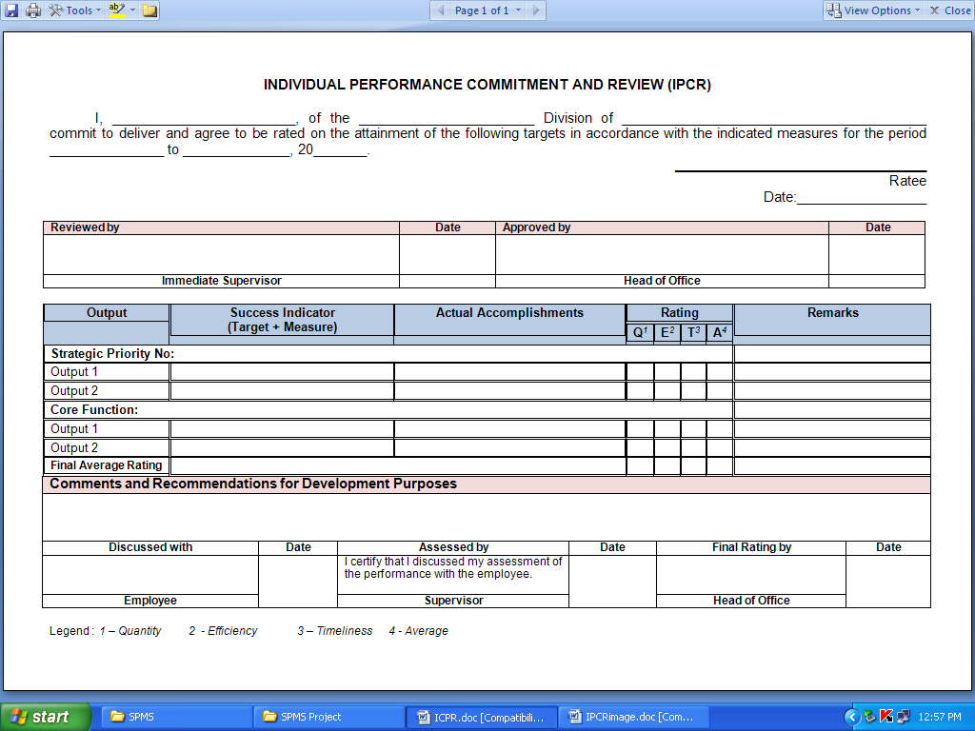

Annex “K”

Annex J Revised 2022

Employee Feedback Form

________________
Date

Name of Employee: _________________________________
Office: _____________________________________________

Nature / Subject of comment / suggestion / complaint:

_____________________________________________________________________________________________________________________________________
_____________________________________________________________________________________________________________________________________
______________________________________________________________.

________________________________________
(Signature over printed Name of client)

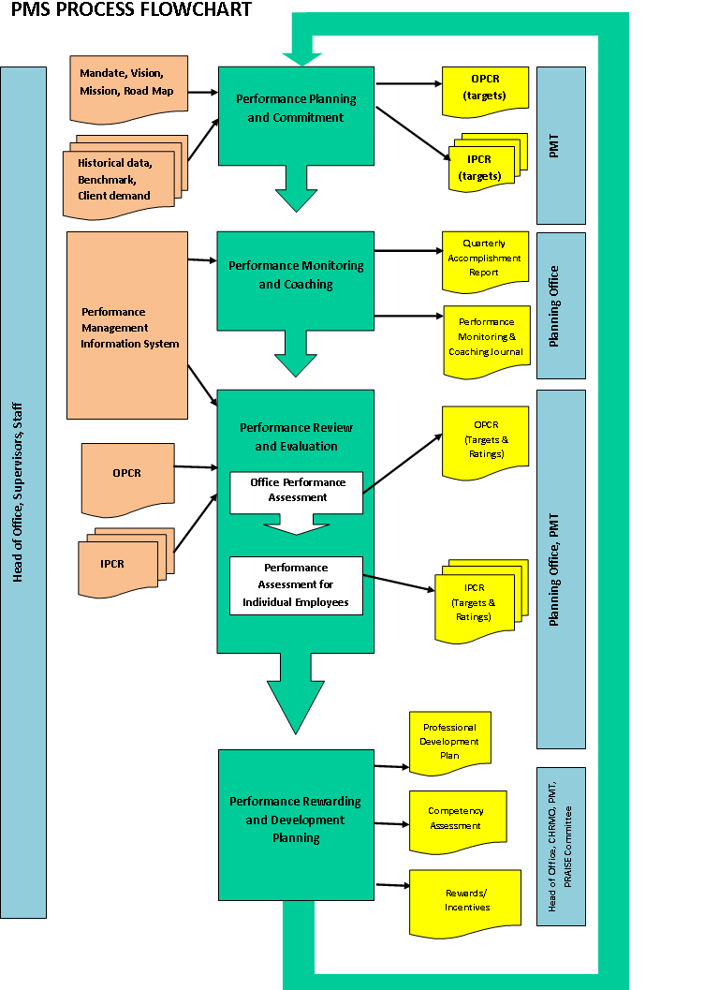
Annex K Revised 2022

Annex L Revised 2022

PERFORMANCE GAP
ACTION FORM
Control No. __________

Critical Incidents: _________________________________________________
_________________________________________________

Schedule of Coaching:
Date: ____________________ Time: ______________ Venue: ___________________________

Person/s Responsible: a. _______________________________________
b. _______________________________________
c. _______________________________________

Action Plan / Remarks: ____________________________________________________________________________
____________________________________________________________________________
____________________________________________________________________________
____________________________________________________________________________
____________________________________________________________________________

Conducted by: Noted:

(Department Head)
___________________________________ _______________________________

Date: ____________________ Date: _______________________

